3-D MODELLING

3D modelling is the process of creating three-dimensional representations of an object or a surface. 3D modelling is used to shape many of the things we see in our everyday lives. 3D modelling technology has benefited our day to day lives in all areas from studies to video games to architecture. Computer-based 3D modelling software are used in a large scale to prepare 3D models.

An object’s size, shape, and texture can be determined during the 3D modelling process. The process works with points, lines, and polygons to create **3D modelling**.

It is the process of developing a mathematical coordinate-based representation of any surface of an object (inanimate or living) in three dimensions. A specialised software is used for developing the representation by manipulating edges, vertices, and polygons in a simulated 3D space.

An artist uses special software to manipulate points in virtual space(called vertices) to form a collection of vertices that form an object referred to as mesh. By changing the form of the mesh or manipulating vertices these 3D objects can be generated automatically or created manually. These points are mapped into a 3D grid and joined together as polygonal shapes, usually triangles or quads. Each point or vertex has its own position on the grid. By combining these points or vertex into shapes, the surface of an object is created.

The project, design, and environmental compliance assessments can all be done with 3D models. To make the 3D model a reality, teams use these control methods to guide equipment to create the lines, points and surfaces exactly as depicted in the model. Pre-bidding also benefits from these models, Contractors may test out different designs and convey ideas.

A process called [**3D rendering**](https://en.wikipedia.org/wiki/3D_rendering) is also used to display the 3D model as a two dimensional image or used in a computer simulation of physical phenomena.

Earlier, many computer games used pre-rendered images of 3D models as sprites before computers could render them in real time. The designer can then see the model in various directions and views, this can help the designer see if the object is created as intended compared to their original vision. Seeing the design this way can help the designer or company figure out changes or improvements needed to be done to the model.

Process for creating 3D models

3D modelling is a unique combination of technical and artistic skills. It's a new arena with a lot of potential in the job market, Many people take is as a great hobby. 3D modelling has various applications that can come in handy in everyday life. The basic idea of 3D modelling is to create three-dimensional shapes which are then visualized in different ways. The final result may be a static scene rendered from a specific angle or a detailed model that can be examined from all angles. When working with 3D, you usually start with a basic geometric shape (a cube, sphere, cylinder, etc.) and tweak it with various modifiers until it resembles what you're trying to create. The main workflow revolves around modifying those shapes on several levels. You can either move the whole object around, or you can break it down into its components and work with them. For example, with a cube, you may select one of its sides and modify it. You could even select just one edge of that side, or work with individual vertices. The primitive is just a starting shape to begin modelling. The artist will build upon this basic form and manipulate it using various modelling tools. For 3D modelling, it’s almost always a good idea to start simple and work towards complexity. Several tools exist to speed up the modelling process. Most programs include a mirroring technique that lets the artist build a symmetrical model by only working on one-half or even one-quarter of the object. This is especially useful in character design as an artist only needs to model one side of the character and the software will mirror their work along the desired axis creating a perfectly symmetrical object. Other tools allow for the quick deformation of a model’s surface.

Steps to start making 3d models for beginers

At a fundamental level, you’ll need to know the building blocks of 3D modeling. Here are the most important terms:

* **Vertex:** A single point and the smallest component of a 3D model.
* **Edge:** A straight line that connect two vertices. Edges define the shape of a 3D model.
* **Polygon:** Any shape that’s formed by connecting straight lines. There are several types of polygons (equilateral, equiangular, regular, irregular, cyclic, convex, concave) depending on the number of sides and the extent of the angles.
* **Face:** The most basic part of a polygon mesh. It is the space between the edges.
* **Mesh:** A collection of polygons that are connected along their edges. A 3D object consists of one or more 3D meshes.

Every 3D modeling program uses a 3D environment, which is made navigable using vectors and planes.

* **Vector:** Indicates directionality and orientation, usually along the 3 axes.
* **Plane:** Two-dimensional surface oriented along one of the 3 axes.

There are three main types of 3D modeling used in CAD software: wireframe modelling, surface modelling and solid modelling.

In addition to the main three, there are some other methods of 3D modeling, which we’ll briefly mention here:

* **Sculpting**uses brushes and other tools to smooth, grab, push, and manipulate surfaces into more organic models.
* **Box modeling**starts with a primitive object like a cube or shape. This object is then transformed into a model. A large portion of an object or whole object is manipulated at a time. Box modeling works best with hard surface modeling.
* **NURBS**stands for non-uniform rational basis spline, a 3D modeling technique used to generate surfaces and curves. Its flexibility and precision make it easier to generate shapes.
* **NURMS**stands for non-uniform rational mesh smooth, a 3D modeling technique used to smoothen meshes.
* **Polygon modeling**makes use of faces, edges, and vertices to edit parts of a 3D model. The shape of an object is altered by changing the coordinates of one or more vertices.

As a beginner in 3D modeling, there are some things that you’re guaranteed to stumble upon on your journey:

* **Deformations** in CAD programs allow a 3D designer to modify the surface of the model. For example, when designing complex models that will require one to do some experiments before getting the right design, deformation tools can be used to create a high polygon count. In this process, the designer can work in a way that preserves the original model. In deformations, the topology of the model isn’t changed.
* **Manipulation** is transforming an already-designed model to suit your needs. Transformation tools in CAD programs are the most widely-used tools for manipulation.
* **Binary operations:** A polygonal modeling operation performed to create a new mesh from two other meshes. Two or more meshes can be joined together or intersected.
* **Measurements:** This is the computation of the values of the mesh. You can measure the following: volume, surface area, cross-section, and also fitting.

Types of 3d modelling

Wireframe modelling

A wireframe model is an exact representation of a real-world, three-dimensional object used in 3D computer modeling. a 3D wireframe model goes together like a network of vertices. Three vertices (or triangles) make the basic element of wireframe models. The geometric face is composed of at least three vertices. You can adjust the shape and dimension of the object by making changes to each vertex position. One or more faces may share the same vertex.More triangles create more realistic models. The “polygon count” indicates the total number of triangles contained within a wireframe model.

The use of wireframe modelling in CAD comes from two major aspects: computer representation of an object, which concerns the structure of the model, and the computational procedures to manipulate visualization of the representation. Wireframe structures contain only two types of information—first, the geometric data in relation to the coordinate positions of connecting points in the 3D model. Second, the topological data that translate connected points as edgesIt is created by specifying each [edge](https://en.wikipedia.org/wiki/Edge_(geometry)) of the physical object where two mathematically continuous smooth surfaces meet, or by connecting an object's constituent [vertices](https://en.wikipedia.org/wiki/Vertex_(computer_graphics)) using (straight) [lines](https://en.wikipedia.org/wiki/Straight_line) or [curves](https://en.wikipedia.org/wiki/Curve_(geometry)). The term "wireframe" comes from designers using [metal wire](https://en.wikipedia.org/wiki/Metal_wire) to represent the three-dimensional shape of solid objects. 3D wireframe computer models allow for the construction and manipulation of solids and solid surfaces. Using a wire-frame model allows for the visualization of the underlying design structure of a 3D model. wire-frame renderings are relatively simple and fast to calculate, they are often used in cases where a relatively high screen [frame rate](https://en.wikipedia.org/wiki/Frame_rate) is neededWireframe modeling allows you to experiment with any shape, colour and style, and because it is so versatile you can build anything from aircraft carriers to ancient Egyptian pyramids.

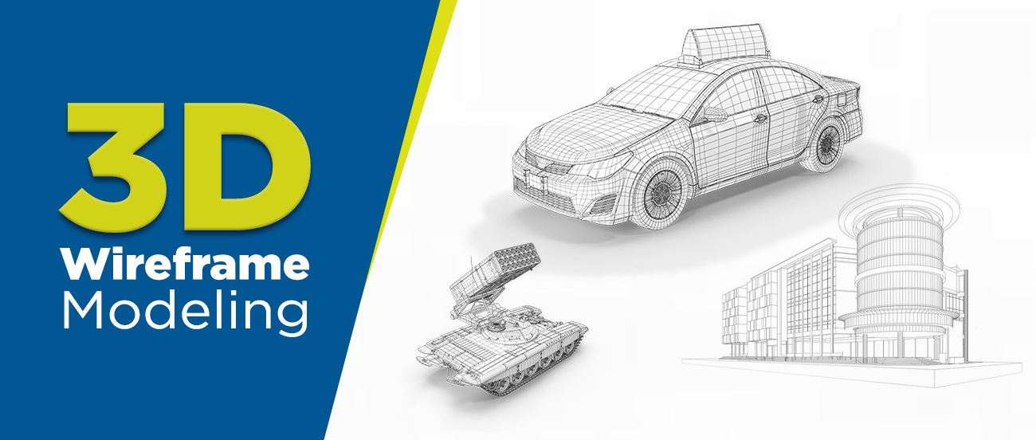

Advantages

### Provides a complete 3D view

This technique is important in 3D modeling as it offers a complete 3D view of the model from all perspectives and angles. Using this, the designers not only get an idea of the future product but also understand its exact dimensions and specifications.

### Close examination of the object composition

The process helps creators get a complete 3D view of the object. It also helps in building a complete design strategy as it provides a close examination of the object’s wireframe and its composition, like distance, potential difference, etc.

### Automates orthographic and auxiliary views

By creating wireframes on 3D, creators get various kinds of views, like orthographic and auxiliary views. Designers can gain a thorough understanding of the model by using these views, as both provide detailed information on how the design and future object will be.

### Suitable for higher frame rate

Wherever a higher frame rate is required, creators can opt for this wireframe modeling method as it helps keep the designs and process streamlined and structurally perfect.

### Simple to construct

[3D modeling](https://professional3dservices.com/blog/what-is-3d-modeling.html) can be a complex process for some, but the wireframe modeling process makes it easy for all. It accomplishes this by simplifying complex designs and assisting designers in creating designs effortlessly.

Diadvantages

### Designs create confusion

The process is a composition of various designs, dimensions, arcs, and other important details. This may cause the process to appear confusing at first, but it gets easier for professionals.

### Not apt for mass calculations and voluminous designs

This technique has its limitations when it comes to mass calculations or when you have to create designs in large volumes. However, it works wonderfully, when it comes to the creation of limited design wireframes.

### Impossible to represent complex solid designs

While you can use wireframe modeling to simplify models, it becomes challenging to do the same for complex solid representations.

### Creates ambiguous views

Ambiguity comes naturally with this modeling process. This is why the models developed through this always remain vague and are not ideally considered to be exact representations of the objects.

Surface modelling

When seamless integration among the edges and a smooth transition from one vertex to the next is required, you need higher computational power to run the right software for building a surface model. The primary purpose of a surface model is to showcase an object in 3D the way it is supposed to be visible in the real world.

Surface modeling relies on an object’s positioning and curvature. It also matters how you can validate imperfections and apply smoothness across the image.

A significant problem with this method is that visual representation of surfaces may contain geometry that cannot exist in the real-world, also known as non-manifold geometry

Surface modelling, focuses heavily on the visual representation of an object’s exterior. The object can be anything from organic shapes like fruits or animals, electronic devices like radio or phone, to complex structures like bridges and skyscrapers. Regardless of the object, surface models require clearly defined curves, contours, and textures of the outer shell.  an object can still be geometrically incorrect – without definite volume or thickness – in a surface model as long as you don’t plan to manufacture the model. This flexibility gives designers the unlimited possibility to shape a model in a way that the solid modeling method cannot. On the other hand, you cannot slice open a surface model since the interior is empty; it is a hollow object.

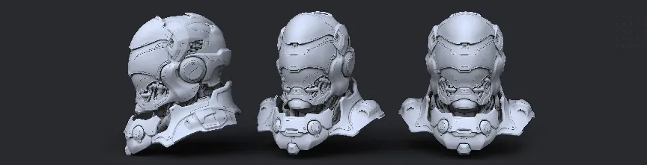

Advantages

* When working with certain design software applications it is not always possible to create or add features to a model, mainly because of software limitations. In such cases surface modelling is important to depict specific features.
* Surface modeling skills are sometimes the only way of creating highly precise complex shapes (usually by working with one face at a time).
* Surface modeling is needed for advanced modeling techniques, like [hybrid modeling](https://www.digitalengineering247.com/article/hybrid-modeling-where-solids-meet-surfaces), where designers switch between solid and surface modeling work.
* This technique allows you to continue working fluidly or to make changes to Dumb solids. These often feature missing data or details when imported into another CAD tool.
* Thanks to modern softwares, surfacing has recently become easier and can be done without the efforts and the trainings that were previously required.

Disadvatages

1. Difficult to construct.
2. Difficult to calculate mass property.
3. More time is required for creation.
4. Requires high storage space as compared to wire frame modelling.
5. Also requires more time for manipulation.

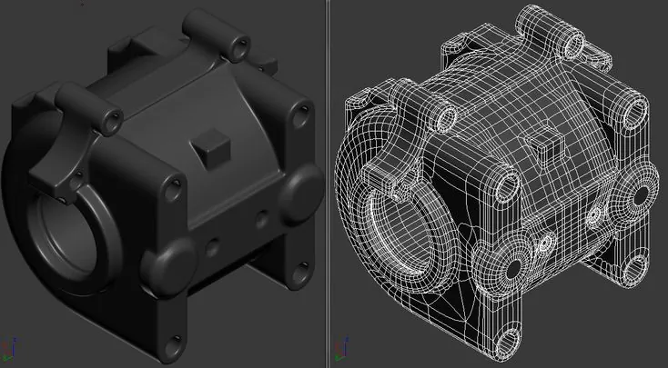

Solid modelling

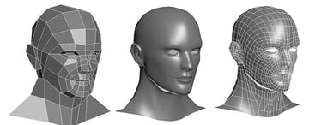

it is a type of modeling where a particular shape or form is being made by the use of CAD software. This technique can be used for almost any product design, whether it is a car or a house.

Solid models must allow for visualization and animation of the inner workings or moving parts of an object. Otherwise, they are concealed under the surface and hidden from plain sight during real-world application. CAD programs use different procedures to build a solid model. Some add solid objects over another combination and placement to produce complex figures. Others extrude shapes from two-dimensional sketches to construct 3D assets.

 solid models almost always come from primitive shapes such as cubes, cylinders, prisms, spheres, and cones. The process can also start with multiple three-dimensional figures, allowing you to create pretty much every imaginable object. That includes not only machines and mechanical elements but also fantastical items and representations of natural things.

There are four key elements of a solid model

* **Complete:**various points within the modelling environment classified as inside or outside. The purpose is to provide accurate division between the object’s surface and all else beneath it.
* **Valid:**edges, faces, and vertices must be connected in proper configuration to deliver a clear view of the 3D object.
* **Unambiguous:**design clarity and certainty. There can only be one single interpretation of all the design aspects drawn. A solid model must be realistic in the sense that the digital object represents its true shape in reality.
* **Solid:**the object needs to have true-to-life topological and geometric data including shape, size, weight, and connectivity of edges.

Advantages

Solid modeling is one of the most important applications of the CAD software and it has been becoming increasingly popular of late. The solid modeling CAD software helps the designer to see the designed object as if it were the real manufactured product. It can be seen from various directions and in various views. This helps the designer to be sure that the object looks exactly as they wanted it to be. It also gives additional vision to the designer as to what more changes can be done in the object.

Solid modeling is used not only for creating solid models of machine parts, but also the buildings, electric circuits and even of the human beings. The solid modeling software are being used for a large variety of applications, here are some of them:

**1) Engineering**: The engineering design professionals use solid modeling to see how the designed product will actually look like. The architects and civil engineers use it to use the layout of the designed building.

**2) Entertainment industry**: The animation industry has been using solid modeling to create various characters and the movies out of them.

**3) Medical industry**: Modern imaging scanners are being used to create the solid models of the internal parts of the body. This helps the doctors to visualize specific tissues of the body, designing various medical devices etc.

Disadvantages

It can be too slow for highly conceptual design. In the early stages, you tend to think faster than anybody can model in 3-D. Almost all of us in the field do preliminary sketches on paper or 2-D CAD before firing up the 3-D modeler. -Requires a lot of computer power. Cheaper these days, but not a neglectible expense. -Some design changes can be slower and harder. -File interchange between 3-D parametric CAD systems is even worse than among 2-D systems. PTC, Solidworks, Autodesk, and the like really need to play better with each other if any of them want to take credit for supporting collaborative work.

Surface modelling VS solid modelling

Solid modeling is for representing solid objects in the areas of CAD, engineering analysis, graphics and animation as well as prototyping and product visualization. It uses mathematical principles to create 3D solid objects.

The object is able to be seen in geographic terms, and is considered a “watertight” model because the internal details of the product are often included. Each part of the model is added one at a time until the complete model is finished. Assembly modeling can also play a part in solid modeling, which is simply when smaller parts of the model make up the whole.

Solid models can intersect, join and subtract objects from one another to create the desired results as far as shape and form.

Surface modeling focuses more on the external aspects of an object. It develops an object by stretching a surface over it with 3D curves created by the designer. It is essentially describing the surface boundaries of the object. It allows the viewer to see at each surface point where the solid interior is located.

This type of modeling is used for creating the external aesthetics of a product or design. It can allow for more free-form shapes and it is considered sleeker by some. It lacks the “watertight” feature of solid modeling because if you were to cut into the design, it would be hollow. This gives solid modeling an advantage over surface modeling because the object can be defined more intricately, giving you a better idea of how the product or design will perform.

Another difference between solid and surface modeling is what they can do while you are developing a design. When developing designs using surface modeling, it can be hard to go back and make changes because they are not parametric. Making changes in one area may not create updates in the whole design. Solid models, on the other hand, are parametric, so you are able to look at the commands you used to create the design.

Each type of modeling serves its purpose depending on the type of design you are working on, so the pros and cons of each should be weighed to see which one will work for the design concept you have so that you can make the best use of their benefits.

Advantages of 3D modelling

**An increase in the accuracy of plans:**Before construction begins, 3D models reveal conflicts, inconsistencies, and other flaws in the designs, which minimizes rework and expenses for the project.

**In-field precision:**Machine operators have an easier time following project plans since the machines have the same data as the surveyor. When traversing a job site, workers won’t have to rely only on contours. The surface of the 3D copy is likewise constructed according to the terrain’s real vertical and horizontal geometry.

**Less expensive surveys:**The use of 3D modeling eliminates the necessity for regular grade verification, which saves surveying expenses. With decreased surveying expenses, you may win more jobs and make more money over time. As your business grows, the increased funds can be used to improve equipment and recruit more staff.

**Improved machine performance:**Because it moves exactly according to the measurements of the 3D model, machinery runs more efficiently. In less time, 3D modeling allows you to get more out of your equipment with less effort. Fuel, repair, and maintenance expenses are all reduced as a result of the enhanced efficiency.

**Reduced costs of basic materials:**Techniques such as 3D modeling can help you get it right the first time and make better use of your material resources. Because you’ll require fewer supplies for each operation, this increased productivity lowers raw material prices. This is a long-term and cost-effective advantage.

**Labor expenses are lower:**Many of the machine operator’s responsibilities are automated with 3D machine control modeling, allowing them to operate faster and with fewer errors – this quality boosts individual worker productivity while lowering labor expenses.

**Better communication:**3D models may be used to communicate project information to diverse stakeholders in a more approachable and visible way. It will be easier to share thoughts and suggestions if everyone has a shared grasp of the topic.

**The number of usages increased:**The data may be put up once and then used for grading, utilities, and hardscaping, among other things. Additionally, you may make changes to the material as needed for future assignments by editing it.

**Cost savings on the project:**According to research by the U.S. Department of Transportation’s Federal Highway Administration, using a 3D model can lower project costs by four to six percent. 3D models may boost efficiency by 15 to 25% in the earthmoving industry alone